**Rotary Pendulum Modeling**

**Topics Covered**

• Interact with the Qඝඉඖඛඍක@ QUBE-Servo 2 Rotary Pendulum system.

• Configure sensor and actuator gains to match model conventions.

**Prerequisites**

• Integration laboratory experiment.

• Rotary pendulum module is attached to the QUBE-Servo 2.

**1 Background**

The rotary pendulum system, also known as the Furuta Pendulum, is a classic system often used to teach modeling and control in physics and engineering. The free-body diagram of a basic rotary pendulum is depicted in Figure 1.1.

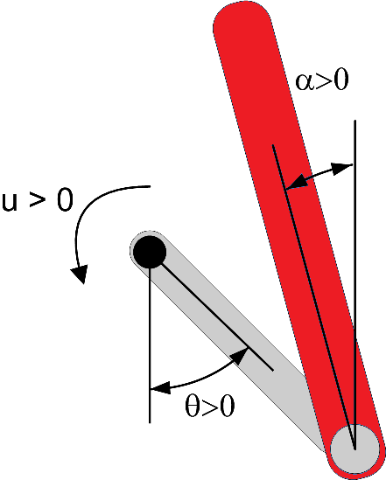

Figure 1.1: Free-body diagram of rotary pendulum

The rotary arm, which is attached to the motor pivot, is denoted by the variable *θ* and the pendulum angle, attached to the end of the rotary arm, is denoted by *α*. Note the following conventions:

• Angle *α* is defined as the *inverted pendulum angle*, i.e. the angle with respect to the upright vertical position where *α* = 0 means the pendulum is perfectly upright. It is expressed mathematically using

*α* = (*αf ull* mod 2*π*) *− π.* (1.1)

where *αf ull* is the pendulum angle measured by the encoder, i.e. the continuous angle measurement defined as zero when pendulum is in the downward configuration.

• Both angles are defined as positive when rotated in the counter-clockwise (CCW) direction.

• When a positive voltage is applied to the motor, the rotary arm moves in the positive CCW direction.

The goal is to design a system model that follows these conventions. The QUBE-Servo 2 Integration laboratory experiment introduced the DC motor and encoders on the QUBE-Servo 2 system. The pendulum angle is also measured using an encoder.

**2 In-Lab Exercises**

In this lab, we will create a LඉඊVIEW™ Virtual Instrument (VI) to drive to the DC motor and measure both the rotary arm and pendulum angles - similarly as shown in Figure 2.1.

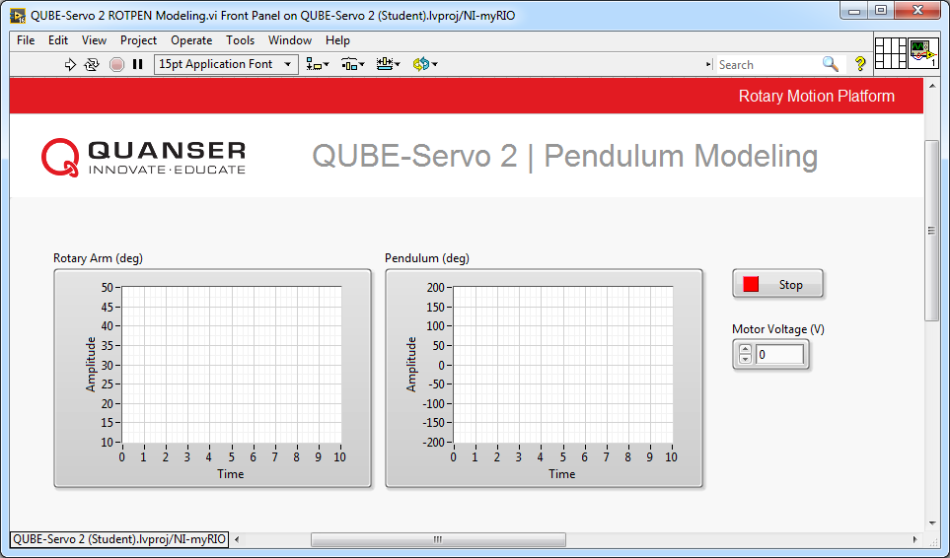

(a) Front Panel

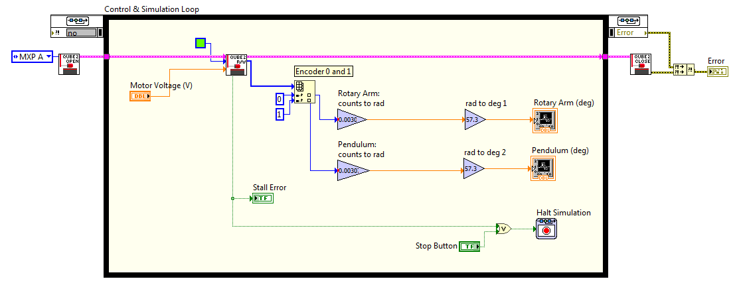

(b) Block Diagram

Figure 2.1: VI used to drive motor and read angles on QUBE-Servo 2 Rotary Pendulum system

1. Based on the VI developed in the Integration laboratory experiment, do the following:

• The QUBE 2 R/W block outputs both the arm and pendulum raw encoder counts. To read the pendulum encoder, expand the input terminals of the Index Array block and wire a Constant block with the value set to 1.

• Setup the encoder gains on each channel to read the angles in radians (instead of degrees).

• Connect the the measured angles to waveform charts, but display them in degrees (usually more intuitive). You can do this by adding Gain blocks that convert radians to degrees.

• Connect a Numeric Control to the *Motor Voltage* terminal of the QUBE 2 R/W block to control the motor voltage.

2. Run the VI.

3. Rotate the rotary arm and pendulum counter-clockwise and examine the response on the waveform charts.

Example responses are shown in Figure 2.2. Do the measured angles follow the modeling conventions given

in Section 1?

4. Apply a small voltage (0*.*5 V) to the motor. Does your VI follow the modeling conventions?

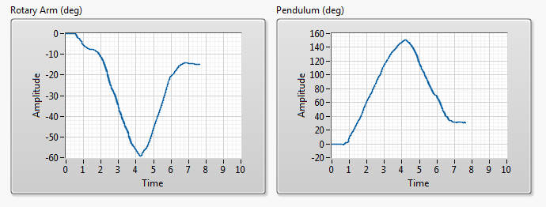

Figure 2.2: Measured rotary arm and pendulum angles

5. Modify the VI such that the measured angles and applied voltage follow by the modeling conventions. Briefly list any changes made.

6. Add modulus and bias blocks, as shown in Figure 2.3, to measure *inverted pendulum angle*, defined as

Equation 1.1.

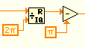

Figure 2.3: LabVIEW modulus and bias blocks

7. Make sure the pendulum is unperturbed in the downward position before starting the controller. Run the VI.

8. Rotate the pendulum to the upright vertical position and ensure the angle is measured correctly and it follows the free-body diagram in Figure 1.1. Capture the response of the pendulum being raise to the inverted position. Explain what the bias and modulus functions do.

9. Click on the Stop button to stop the VI.

© 2017 Quanser Inc., All rights reserved.

Quanser Inc.

119 Spy Court

Markham, Ontario

L3R 5H6

Canada

[info@quanser.com](mailto:info@quanser.com)

Phone: 1-905-940-3575

Fax: 1-905-940-3576

Printed in Markham, Ontario.

For more information on the solutions Quanser Inc. offers, please visit the web site at:

[http://www.quanser.com](http://www.quanser.com/)

This document and the software described in it are provided subject to a license agreement. Neither the software nor this document may be used or copied except as specified under the terms of that license agreement. Quanser Inc. grants the following rights: a) The right to reproduce the work, to incorporate the work into one or more collections, and to reproduce the work as incorporated in the collections, b) to create and reproduce adaptations provided reasonable steps are taken to clearly identify the changes that were made to the original work, c) to distribute and publically perform the work including as incorporated in collections, and d) to distribute and publicly perform adaptations. The above rights may be exercised in all media and formats whether now known or hereafter devised. These rights are granted subject to and limited by the following restrictions: a) You may not exercise any of the rights granted to You in above in any manner that is primarily intended for or directed toward commercial advantage or private monetary compensation, and b) You must keep intact all copyright notices for the Work and provide the name Quanser Inc. for attribution. These restrictions may not be waved without express prior written permission of Quanser Inc.